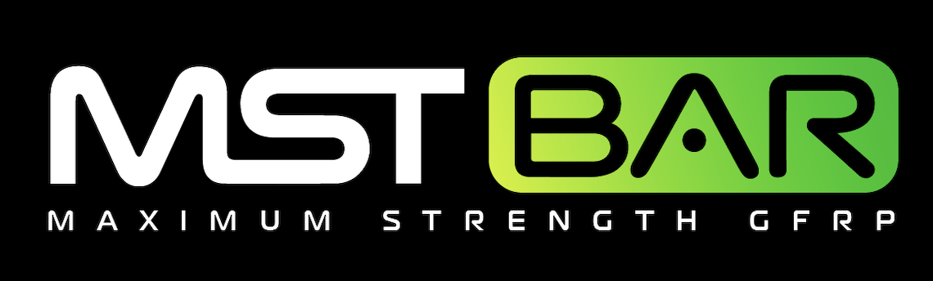
June 16, 2021

SUBJECT: Use of 4EQ Structural Bar® as a 1:1 replacement for #4 Grade 60 Reinforcement in residential foundations

To Whom It May Concern:

4EQ Structural Bar® is a high-strength composite reinforcing rebar from MST-BAR®. It is ICC-ES listed in ESR-4664. This Structural Fiberglass Rebar is made with Vinyl Ester Resin & corrosion-proof ECR Glass Fibers with the following properties:

BAR DIMENSIONS 0.45 in Diameter
CROSS-SECTIONAL AREA 0.16 in2
TENSILE STRENGTH 165 ksi
ELASTIC MODULUS 7550 ksi
SHEAR STRENGTH 27 ksi
PULL-OUT CAPACITY 2900 psi

The 4EQ Structural Bar® reinforcement may conservatively replace standard slab on grade reinforcement one to one at spacing noted on plans. It is also a replacement for standard #4 reinforcement in residential foundations including spread and continuous footings, basement walls, stem walls, and piers. Contact engineering for wall reinforcement replacement of #5 and #6 rebar.

Always wear gloves when handling 4EQ Structural Bar® to protect against fiberglass splinters. Avoid direct contact with skin. When cutting 4EQ™ Fiberglass Rebar, use a diamond blade for best results. Tie and chair 4EQ Structural Bar® as you would steel rebar. Generally, minimum lap splice length of 27 inches unless otherwise specified by the engineer of record.

The information in this letter is valid until 12/31/2022 when it will be re-evaluated by TUF-N-LITE. Please visit mstbarusa.com for additional pertinent information. If you have questions or need further assistance regarding this matter, please contact TUF-N-LITE engineering at 925.750.0100

Sincerely,
TUF-N-LITE

COMPOSITE REBAR PRODUCTS

